**An Analysis on Mark-18A Target Irradiation History and Inventory of Plutonium and Heavy Curium**

Benjamin Austin, W. Cade Brinkley, Jennifer Jeffcoat, Jacob Weinberg, Benjamin Beeler

**Abstract**

From 1969 to 1979, the Savannah River Site (SRS) produced and managed heavy isotopes as directed by the DOE. This was accomplished by exposing 86 highly enriched Pu-242 Mk-18A Outer Housing (OH) targets to high neutron fluxes in the K-Reactor with the initial intent to produce Cf-252 [1]. Although this directive was abandoned just over a year later, the plutonium targets continued their exposure in an effort to produce Pu-244 for the duration of the decade. After decommissioning, 21 of the targets were transferred to Oak Ridge National Laboratory (ORNL) to extract the accumulated Cf-252. The remaining 65 Mk-18A targets remained in water basin storage located at SRS. The purpose of this study is to model the irradiation history of the core and the decay of isotopes to approximate the inventory of each individual target.

# Introduction

The high flux Californium I irradiation campaign began August 11, 1969 and ended November 8, 1970. During this time, 86 Mk-18A targets with high enriched Pu-242 were exposed to a high neutron flux in an effort to produce Cf-252 [1]. Californium is a synthetic radioisotope produced in reactors via multiple neutron capture reactions, which is a highly sought-after neutron source. With a half-life of 2.6 years and a 3% natural fission decay rate, it has uses in medicine, reactor startup [12], metal detectors [13], etc. There are only 2.625 grams of Cf-252 produced annually worldwide [11]. Figure 1 shows the rationality behind using enriched Pu-242 instead of natural uranium for the campaign, in that the number of neutrons required to produce a single atom of Cf-252 is reduced by nearly a factor of 10.

|  |
| --- |
|  |
| *Figure 1: Production chain of Californium 252 from Uranium 238 (Public Domain).* |

Between 1972 and 1973, 21 of the 86 Mark 18-A targets were processed to recover Cf-252, heavy curium, and plutonium. The extraction of these isotopes was applied to industrial applications and the discovery of new transactinides. SRS currently houses the majority of the world’s heavy curium and plutonium in the remaining 65 targets. The supply of these isotopes from the 21 processed targets is expected to deplete by 2030 [1].

In 2012, SRS was appointed to address the disposal or recovery of the remaining 65 Mark 18-A targets. This study assessed seven alternatives for the disposition of the Mark-18A: five unique choices for recuperation of the materials for later use, a fractional recuperation choice, and a possibility for disposing of the Mark-18A material as waste. The investigation recommended that the targets be processed to recover the essential Pu-244 and heavy curium and move the materials to ORNL for capacity and future advantageous use. [10]

In this work the contents of the remaining 65 targets will be analyzed by utilizing a computational method to determine the mass concentration of the Pu 244 and heavy curium. The results will be used to elucidate which assemblies should be processed first by SRS to recover Pu 244 and heavy curium. The results are not expected to be accurate due to specifications about the Mark 18A targets being classified. Hence, the computational model is made with calculated and assumed variables, such as flux profile, enrichment, and geometric assumptions. However, the qualitative assessments of isotopic concentrations will be utilized by SRS to determine processing schedule and priority for the various target assemblies.

**Computational Methods**

The K-reactor core consists of a hexagonal lattice of annular driver assemblies as shown in figure 2 [3]. It is cooled/moderated with heavy water and its 6 coolant loops enable high neutron fluxes by dissipating approximately 18 MW per assembly of thermal energy [6]; ideal for isotope production.

|  |
| --- |
|  |
| *Figure 2: Face Map of the K-reactor located at SRS [3].* |

Many design specifics of the K-reactor are classified. The enrichment of the drivers, geometry and location of the 90 assemblies used [5], peaking factors, fuel to moderator ratio, and other parameters that are necessary when modeling a full reactor core can only be known to a best estimate using declassified material. Because of this, irradiation histories were modeled one assembly at a time in an effort to mitigate any sources of error that may propagate throughout the model. A consequence of this method is the need to develop a flux distribution function. This was achieved assuming a sinusoidal radial distribution, a radial peaking factor of 1.35, and equations 1 and 2:

|  |  |
| --- | --- |
| $$q(r)=q_{0 }cos(r)$$ | (1) |
| $$F_{r}=\frac{q_{0}}{\frac{1}{πR^{2}}\int_{0}^{R}{}2πrq(r) dr}$$ | (2) |

Since the dimensions of the core were unknown and the placement of the targets was provided in cartesian coordinates, the x and y indices were utilized (and normalized to $π/2$) resulting in equation 1 becoming:

|  |  |
| --- | --- |
| $$q(x,y)=q_{0}cos(\sqrt{x^{2}+y^{2}})$$ | (3) |

and equation 2 becoming:

|  |  |
| --- | --- |
| $$F_{x,y}=\frac{q_{0}}{\frac{1}{π}\int_{-2}^{1}{}\int_{-\sqrt{1-x^{2}}}^{\sqrt{1-x^{2}}}{}q(x,y) dy dx}$$ | (4) |

Figure 3 shows the general shape of the flux profile using this method.

|  |
| --- |
|  |
| *Figure 3: Presumptive shape of the K-Reactor’s flux profile with exaggerated amplitude for visualization.* |

|  |
| --- |
|  |
| *Figure 4: Sketches of MK-14, 16, and 22 Tubes that were used in later irradiation cycles after the Cf production campaign [2]* |

The model assumes that each assembly consists of three inner concentric uranium-aluminum alloy annuli that are 6 ft tall, referred to as the drivers (as seen in figure 4), and a single plutonium-aluminum alloy annulus, referred to as the target, around the middle four feet of the drivers [6]. The drivers are assumed to share dimensions with 2, 2.5, and 3-inch schedule 10 aluminum pipe while the target is assumed to share the dimensions of a 3.5-inch schedule 40 aluminum pipe. Additionally, the initial amounts of the activated isotopes in the target and the amount of fuel in the three driver rings throughout their lifetimes is known. This is used to find the isotopic density of the relevant material with the known geometries as shown in equation 5.

|  |  |
| --- | --- |
| $$ρ_{x}=\frac{m_{x}}{V_{x}}$$ | (5) |

The Mk-18A drivers used in the first irradiation cycle contained a nominal amount of 180 grams of U-235. The subsequent cycles utilized Mk-14 (1500 g/assembly U-235), Mk-16 (3000 g/assembly U-235), and Mk-22 (3400 g/assembly U-235) drivers [5].

# SCALE

# 

# Results

A unique input file was generated for each of the sixty-five assemblies, each with a unique flux history. The masses of specific isotopes were monitored over the lifetime of operation in-reactor, as well as after the shut-down period of the K-reactor. The shut-down period was modeled using two points of time: the first when the reactor shut down, and the second as 15,000 days (41.1 years) after that event. The isotopes analyzed following the SCALE cases were Pu-244, Cm-242, Cm-243, Cm-244, Cm-245, Cm-246, Cm-247, Cm-248, and Cm-250.

As the primary objective of this study was to determine which assemblies produced the most Pu-244 following their initial exposure, the first isotope investigated was Pu-244. The overall trend of the Pu-244 concentration as a function of time is shown in figure 5.

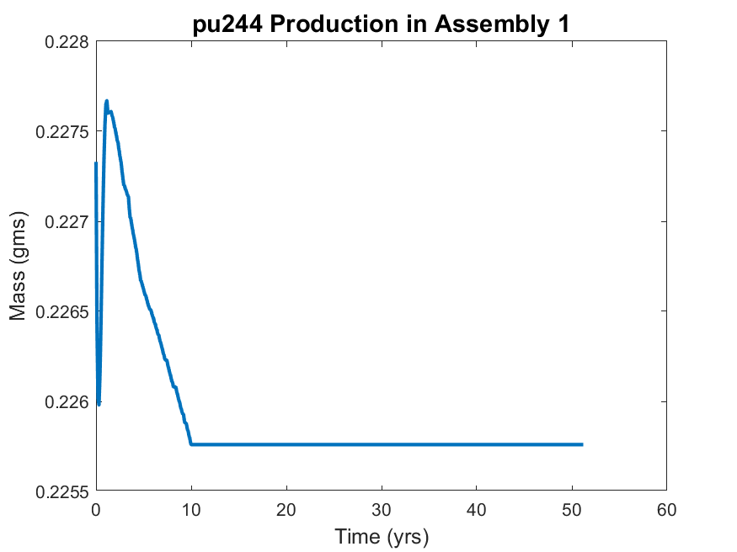

*Figure 5. The production of Pu-244 in assembly 1. The assembly was irradiated for 10 years before being put into storage for 40 years.*

Initially, there were 0.2273 g of Pu-244 in the assembly. In the first few months of operation, the plutonium concentration in assembly 1 decreased before rising to a maximum of 0.2277 grams. This maximum occurs 1.14 yrs into the irradiation history. The plutonium concentration subsequently decreased until the K-reactor shut down (t = 10 yrs). The SCALE simulation calculated no change in the Pu-244 concentration following the K-reactor shutdown, which is expected as the half-life of Pu-244 is XXX yrs. To better understand how the plutonium concentration varies between the assemblies, the assemblies with the most and least Pu-244 during reactor operation and shutdown are tabulated below.

|  |  |  |  |
| --- | --- | --- | --- |
| **Most Remaining** | | **Least Remaining** | |
| **Assembly No.** | **Mass (mg)** | **Assembly No.** | **Mass (mg)** |
| 46 | 226.6 | 36 | 224.9 |

*Table 1. Tabulated values for the Pu-244 masses in the assemblies that currently contain the most and least remaining Pu-244 by mass.*

At the end of the simulation, assembly 46 had 226.6 mg of Pu-244 and assembly 36 had 224.9 mg of Pu-244. To better understand the trends in plutonium production in the assemblies, the production trends for both assembly 46 and 36 are visualized below in figure 6.

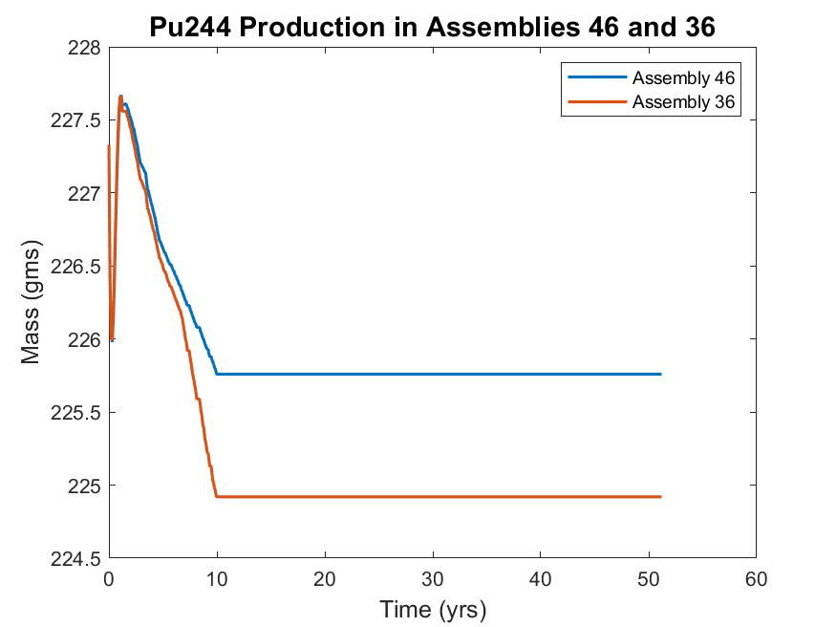

*Figure 6. Plutonium production during reactor operation and shutdown in assembly 46 and 36. The reactor was shut down at approximately t = 10 yrs.*

It is apparent that regardless of the final inventory in the assemblies, the Pu-244 concentration in assembly 36 and 46 reached the same maximum approximately 1 year into the irradiation history. Following the maximum at 1 yr, the plutonium concentration in assembly 36 decreased at a faster rate compared to assembly 46. Following the reactor shutdown (t = 10 yrs) there was no change in the plutonium concentration in the model. The plutonium production was found to be related to the production of the Cf-252. Figure 8 shows the production of Cf-252 in the assembly that produced the most (assembly 36) and the assembly that produced the least (assembly 46).

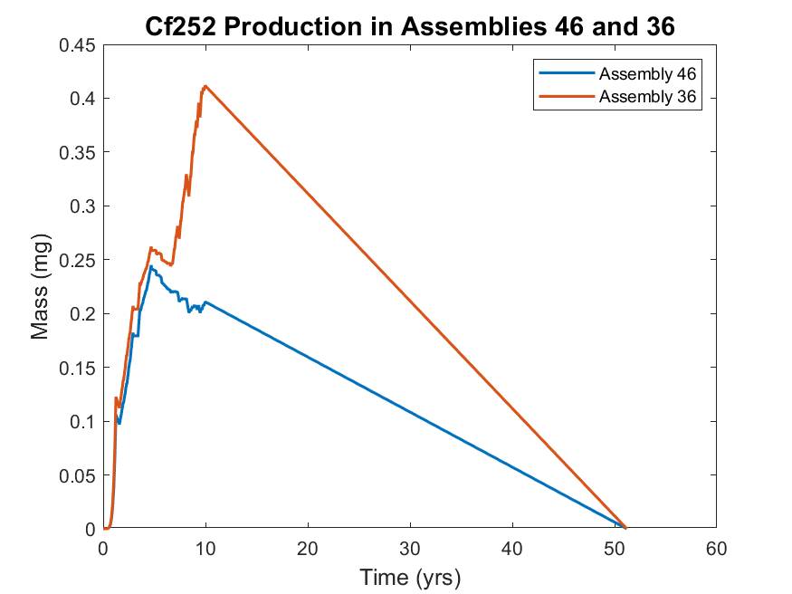

*Figure 7. Production of Cf-252 in assemblies 36 and 46. There are local maximums at 5 years and 10 years for assemblies 46 and 36, respectively. The reactor is shut down after 10 years.*

The initial purpose of the program was to create Cf-252, which has already been described as a strong neutron source [1]. Assembly 46, which was found to have the highest amount of Pu-244 at the simulation end, was found to produce the least amount of Cf-252. Contrarily, assembly 36 produced the least amount of Pu-244 and produced the highest amount of Cf-252. Further, leading up to the reactor shut down the amount of Cf-252 increased by approximately 0.15 mg in assembly 36 while the Cf-252 concentration showed no significant increase. As expected, all of the Cf-252 decayed away by the simulation end. So, a relationship between the Cf-252 production and Pu-244 is identified: assemblies with a greater production of Cf-252 produced the least amount of Pu-244.

Another element that was of interest to SRS was curium (Cm), specifically heavy curium (Cm-246, Cm-247, Cm-248), though all Cm isotopes were tracked and simulated. The final inventories of Cm in the most- and least-producing assemblies are tabulated below.

|  |  |  |  |  |
| --- | --- | --- | --- | --- |
|  | **Most Remaining** | | **Least Remaining** | |
| **Isotope** | **Assembly** | **Mass (mg)** | **Assembly** | **Mass (mg)** |
| **Cm-242** | 14 | 0.0031 | 36 | 0.0014 |
| **Cm-243** | 32 | 0.2376 | 42 | 0.1503 |
| **Cm-244** | 57 | 5458 | 30 | 5319 |
| **Cm-245** | 56 | 949.0 | 39 | 930.3 |
| **Cm-246\*** | 39 | 3460 | 46 | 2613 |
| **Cm-247\*** | 39 | 100.2 | 46 | 67.30 |
| **Cm-248\*** | 39 | 56.23 | 46 | 29.55 |
| **Cm-250** | 36 | 1.128 E-5 | 46 | 4.940 E-6 |

*Table 2.* *Tabulated inventories of all tracked curium isotopes. Assembly 39 contained the most heavy curium and assembly 46 contained the least amount of heavy curium.*

*\*Isotopes considered parts of heavy curium are denoted with an asterisk.*

The isotopes of Curium that were found to be high mass concentrations were Cm-244, Cm-245, and Cm-246. The masses of Cm-250 are significantly smaller than the other isotopes listed and are not included in the following analysis. The assembly that has the highest heavy curium inventory is assembly 39, while assembly 46 produced the least amount of heavy curium. As previously shown, assembly 46 was also found to contain the most Pu-244. Figures 8, 9, and 10 show the production of the heavy curium isotopes.

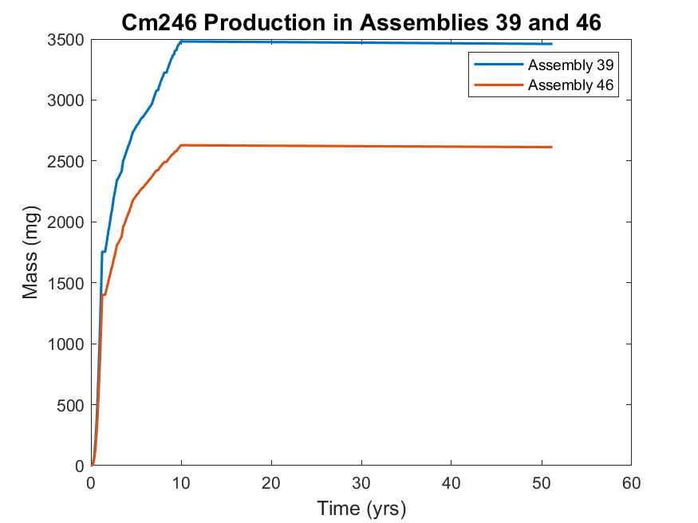

*Figure 8. Cm-246 production in assemblies 39 and 46. Assembly 39 produced the most Cm-246 and assembly 46 produced the least amount of Cm-246. There is no calculated change in the mass concentration after reactor shutdown at 10 yrs.*

The production of Cm-246 appeared to be similar among the two listed assemblies until approximately 8 years into the reactor operation. The inventories diverged slightly before reaching their final inventory. The difference in the final masses is 847 mg.

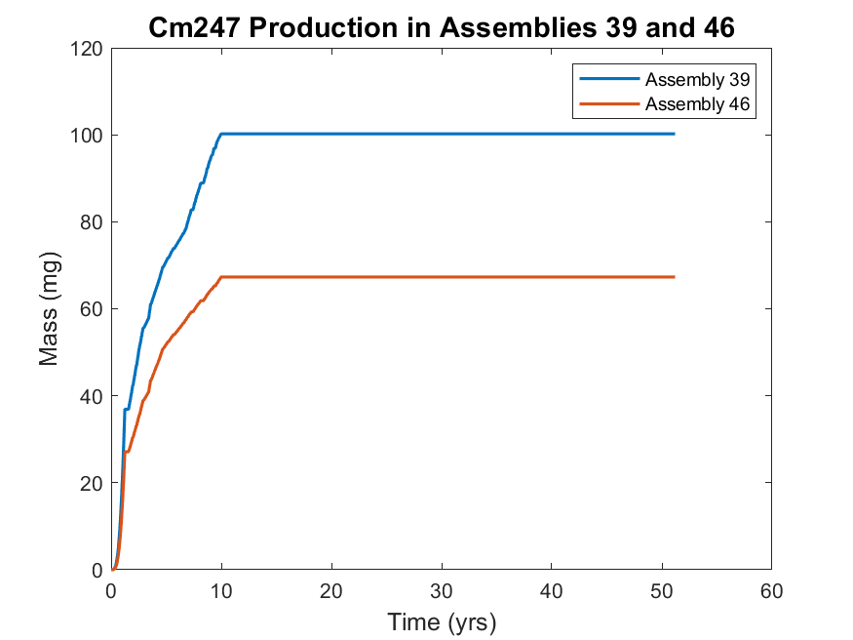

*Figure 8. Cm-247 production in assemblies 39 and 46. Assembly 39 produced the most Cm-247 and assembly 46 produced the least amount of Cm-246. There is no calculated change in the mass concentration after reactor shutdown at 10 yrs.*

Similar to the Cm-246 production trends, assembly 39 produced the most Cm-247 and assembly 46 produced the least amount of Cm-247. The difference in inventories is not as large as the Cm-246 case with a difference of 32.9 mg.

Of the heavy curium isotopes, Cm-248 was produced in the lowest quantities. The difference in inventories at the end of simulation was 26.68 mg.

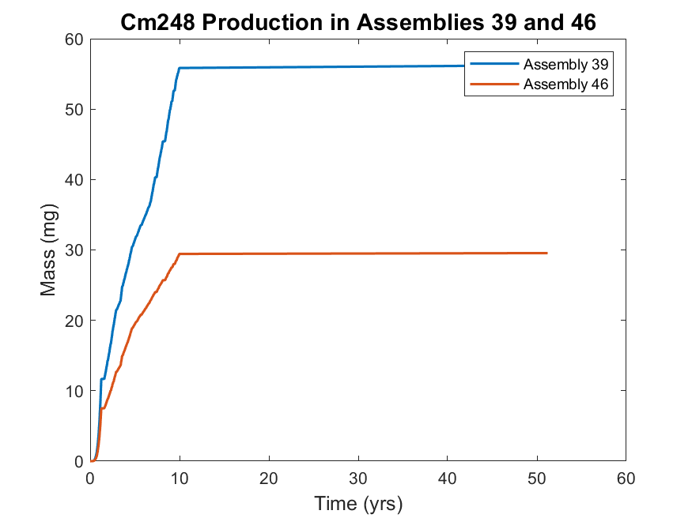

*Figure 10. Cm-248 production in assemblies 39 and 46. Assembly 39 produced the most Cm-248 and assembly 46 produced the least amount of Cm-248. There is no calculated change in the mass concentration after reactor shutdown at 10 yrs.*

**Discussion**

Including all 65 assemblies, a total of 196.8 g of heavy curium was produced. Of which, assembly 39 produced 3616 mg (1.84 %) and assembly 46 produced 2710 mg (1.37%). Thus, while there is a noticeable difference in the final inventories of the individual assemblies, the actual contribution to the total heavy curium inventory is similar.

It is also observed that a lower production of Cf-252 corresponds to a higher production of heavy curium isotopes (see figure 7). This relationship was already identified between Cf-252 and Pu-244, indicating that Cf-252 production can be used to predict which assemblies were also significant producers of Pu-244 and heavy curium. Assembly 46 produced the most heavy curium and Pu-244 and produced the least Cf-252, while assembly 36 contributed the most Cf-252, the least Pu-244, and the XXX (fourth, third? Etc.) least heavy curium. The differences between the assemblies in the production of Cf-252 is plotted below.

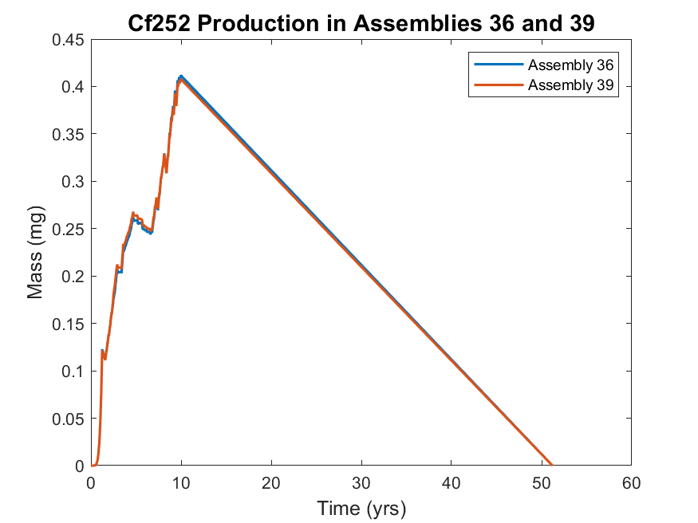

*Figure 10. Cf-252 production in assemblies 36 and 39. It can be seen that there is no significant difference in the production of the isotope. After 10 years, assembly 36 has produced slightly more Cf-252.*

As shown in figure 10, the differences in the production of Cf-252 in assemblies 36 and 39 are insignificant. Therefore, the observation relating Cf-252 production and Pu-244 and heavy curium production is still supported by the results.

The full isotopic analysis is included in the appendix.

# Conclusion

From 1969 to 1970, a Cf-252 production campaign was conducted at the SRS. Following the processing of 21 assemblies, the remainder of the targets were exposed in the K-reactor and subsequently put into storage after 10 years of irradiation. This study was done to determine the current inventories of key isotopes and investigate the trends in their production. Using SCALE, 65 individual simulations were performed to analyze and estimate the isotopic production and decay in each assembly. An analysis was then conducted on each assembly dataset to determine which assemblies produced the most Cf-252, Pu-244, and heavy curium. It was found that the more Cf-252 an assembly produced, the less Pu-244 and heavy curium was present at the end of simulation. Assembly 46 is calculated to contain the most Pu-244 and heavy curium and assembly 36 and 39 were found to have the least Pu-244 and heavy curium. The results lend to a strategy of tracking one isotope, such as Cf-252, in order to predict which assemblies will contain more Pu-244 or heavy curium, which can significantly reduce computational time and logistical costs associated with processing these Mk-18A targets.

# 

# Acknowledgments

This project is supported by Dr. Tracy Stover and Ms. Tara Smith from the Savannah River National Laboratory and advised by Dr. Benjamin Beeler from North Carolina State University. SCALE was acquired through the Radiation Safety Information Computational Center at ORNL. SCALE computations are completed through the Reactor Dynamics Fuel Modeling Group High Performance Cluster at North Carolina State University, managed by Dr. Pascal Rouxelin.

# Appendix A (Core Placement):

# Appendix B (Irradiation History):

# Appendix C (Cumulative Results):

# Work Cited

1. SHARON ROBINSON & BRAD PATTON, *“Mark-18A Target Materials Recovery Study”,* Oak Ridge National Laboratory, 2015

2. WILLIAM P. BEBBINGTON, “*History of Du Pont at the Savannah River Plant”*, E. I. du Pont de Nemours and Company, 1990

3. WADE BICKFORD, “*Estimate of Fission Products in the Mark-18A OH Targets”*, Westinghouse Savannah River Company, 2003

4. N.P. BAUMANN to M.M. ANDERSON, Estimates of 134Cs, 137Cs, and 90Sr in Mk-18 Targets, DPST-79-481, August 30, 1979, Savannah River Laboratory, Aiken, SC

5. DPSOP-134, SRP Reactor Assemblies, page 2204, Mark 18A, Savannah River Laboratory, Aiken, SC

6. DPSTM-18-51-P, Technical Manual Californium Physics, 7/1/69, Savannah River Laboratory, Aiken, SC

7. R.G. BAXTER, Actinide Properties and Methods of Production, DP-1269, December 1972. Savannah River Laboratory, Aiken, SC

8. D.A. WARD to L. HIBBARD, Actinide Content of Mark 18 Outer Housings, RTM-4269, August 14, 1979. Savannah River Laboratory, Aiken, SC

9. J.T. BERRY to D.A. WARD, Actinide Content of Mark 18 Outer Housings, RTR-1825, Page 14-16, March 2, 1979, Savannah River Laboratory, Aiken, SC

10. S. M. Robinson et al., Evaluation of Disposition Options for Mark-18A (Mk-18A) Target Materials, ORNL/TM-2013/148R1, 2014.

11. National Research Council (U.S.). Committee on Radiation Source Use and Replacement (2008). Radiation Source Use and Replacement: Abbreviated Version. National Academies Press. ISBN 978-0-309-11014-3.

12. O'NEIL, MARYDALE J.; HECKELMAN, PATRICIA E.; ROMAN, CHERIE B., eds. (2006). The Merck Index: An Encyclopedia of Chemicals, Drugs, and Biologicals (14th ed.). Merck Research Laboratories, Merck & Co. ISBN 978-0-911910-00-1.

13. OSBORNE-LEE, I. W.; ALEXANDER, C. W. (1995). "Californium-252: A Remarkable Versatile Radioisotope". Oak Ridge Technical Report ORNL/TM-12706. doi:10.2172/205871.